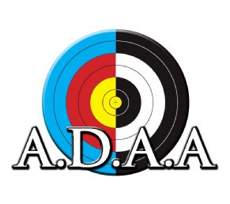
2016 Auckland District Archery Association Indoor Championships
DATES 16 – 17 July
Round to be shoot: Single WA 60 18 metre round
Due to space restrictions on the line, this competition will be shot in flights, please state your preferred date and time below, plus your 2nd preference should your first choice be unavailable.
Saturday: Bow inspection at 9AM followed by first sighting arrow at 9.30 AM
2nd flight: Bow inspection at 1 PM followed by first sighting arrow at 1.30 PM
Sunday: Bow inspection at 9AM followed by first sighting arrow at 9.30 AM
2nd flight: Bow inspection at 1 PM followed by first sighting arrow at 1.30 PM
Venue: Mountain Green Archery Club Indoor Range, under the Waitakere Badminton Centre, 149 Royal Rd, Massey. Parking at rear of the building.
Results will be posted on the ADAA website on the final date at 8 PM. Medals will be awarded by Post to your club.
This is a World Archery registered tournament so National uniform, club uniform and Archery NZ dress code applies.
Entry fee: $30
Cheques made out to “Mountain Green Archery Club Inc”
Entries to: Mountain Green Archery Club,
P O Box 19086, Avondale
Auckland 1746
Email: mgactournaments@gmail.com
Entries must be in by 8 July 2016. Entries will be confirmed once payment is received.

Name: ________________________________ Club: _____________________________
ANZ Affiliation Number: __________________ Email: ____________________________
Mobile: ________________________________

Recurve  Compound  Crossbow  Longbow  Barebow | Male  Female | 65+  50-64  Open  Junior  Cadet  Intermediate  Cub  Kiwi | Preferred flight:  Saturday AM  Saturday PM  Sunday AM  Sunday PM  2nd Preference:  Saturday AM  Saturday PM  Sunday AM  Sunday PM

For email entries: Bank account number 02-0110-0091898-00, please use your surname as reference and “ADAA Indoors” in the details

